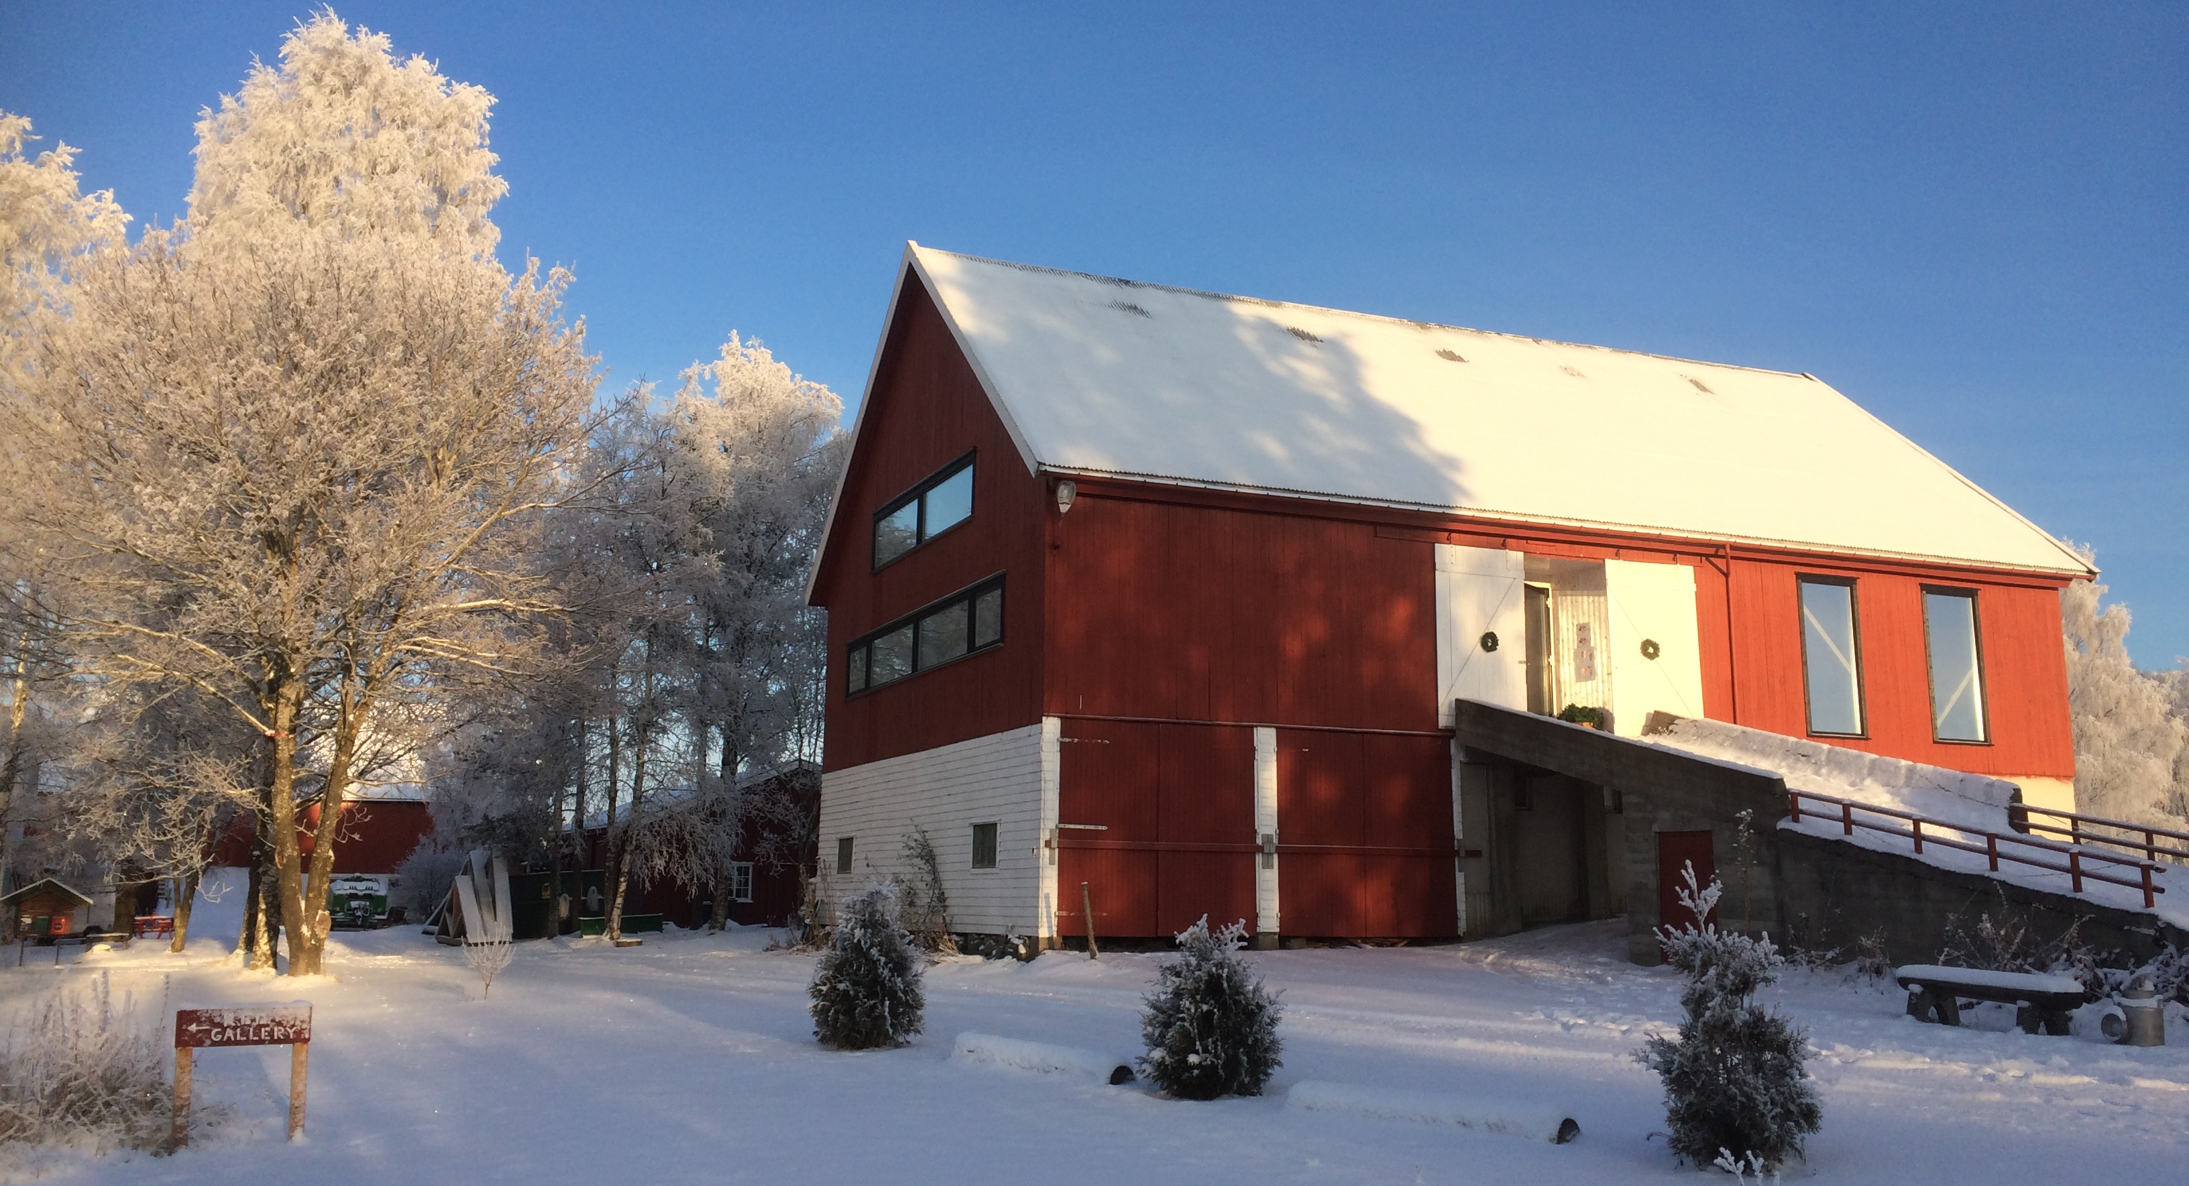
Application form Artist in Residency Program at R.E.D.
Application deadline:
1st of March for the summer residency between 1st May and 1st September
15th of October for the Open Showcase on the 1st Sunday in Advent
Please submit the form in English or Norwegian to: red.residency.danz@gmail.com

Applicant
Group: ……………………………………………........................................................................................................................
Artistic director: ...................................................................................……………….....................……..........................
Address: ………………………………………………………………………..........................................................................................
Postcode/City: ........................................................... Country: ...............................................................................
Tel.: ........................................................................... Mobile: .................................................................................
E-Mail: ....................................................................... Homepage: www....................................…............................
Contact person: ........................................................................................................................................................
E-Mail: ...................................................................……..........………...........................................................................
Tel.: ..............................................................…………… Mobile: .................................................................................
Applying for:
Summer recidency ……………. Open Showcase with residency …………….. Open Showcase ……………….….

Project description
Working title: ............................................................................................................................................................
Genre: ........................................................................ Number of participants: …....................................................

Date: Signature:
Details of Project
Short description:

Theme:

Planned timeframe -Preparation, rehearsals, premier-:

Project participants -Name, role/task in project-:

Planned outcome of residency (work in progress/performance/lecture/etc):

Additional, necessarily put in documentation:
O project description including a short description of your motivation to apply for the residency
O Link to Vimeo/You tube- for previous or current work
O CV and Press coverage (max. ½ page per person)
O other: ..............................................................................................................................................................

Requirements
Studio, rehearsal and workspace requirements:
(Please inform us about the required needs, primarily in the production room/studio)

Minimum size: ........................................................... Minimum height: ...................................................................

O heated studio (sprung dance floor 12x19m) O access to the woods O field O wood workshop
O gallery 3 exhibition rooms in basement O small screening room O café theatre with 3,5x3,5 stage

Special requirements: .........................……………..…...................................................................................................
..................................................................................................................................................................................

Preferred dates of residency– not binding (summer: max. 2 weeks between 1st May and 1st September):
...............................................................................................................................................................................................................................
alternative: ............................................................................................................................................................................................................

Number and role of project participants who will be present during the project on R.E.D.):
For the whole project: ..............................................................................................................................................
..................................................................................................................................................................................
..................................................................................................................................................................................
Temporarily: .............................................................................................................................................................

(The details on this page are for us to understand the size of the project and your potential demand. Please contact us if there are any major changes.)

Any additional comments, wishes, needs, ideas or suggestions:

……………………………………………………………………………………………………………………………………………………………………………...
……………………………………………………………………………………………………………………………………………………………………………...

For the statistic, how did you get to know about the call for application?
……………………………………………………………………………………………………………………….……………………………………………………..

